Code Quality Report
GEAR
(Process Control Metrics)

Reader Name: DM260-3D3420
Device Type: DM260
Serial Number: 1A1615XN007410
Software Version: 5.7.0_sr2
Trigger Index: 4849
Result (raw):
Overall Result: PASS Specification: AIM-DPM Symbology: Data Matrix
Symbol Size: 20 columns / 20 rows
Pixel Per Cell: 3.680

Image:
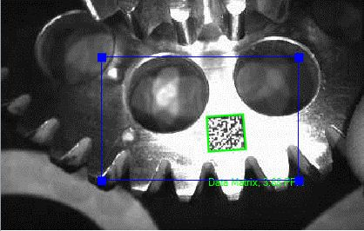

Detailed Results:

Quality Parameter | Result (Raw) | Grade | Min | Max | Avg | Dev
Overall Grade |  | A
Cell Contrast | 0.578 | A | 0.449 | 0.817 | 0.696 | 0.083
Axial Non Uniformity | 0.056 | A | 0.001 | 0.199 | 0.064 | 0.026
Print Growth | -0.039 |  | -0.039 | 0.156 | 0.090 | 0.036
UEC | 1.000 | A | 0.000 | 1.000 | 0.676 | 0.259
Cell Modulation |  | A
Fixed Pattern Damage |  | A
Grid Non Uniformity | 0.172 | A | 0.009 | 0.707 | 0.348 | 0.134

